**DT Backend WebDev Challange**

**Task 2 - API documentation**

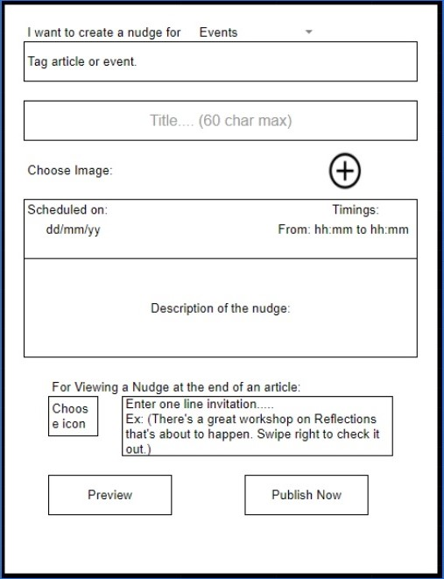

Wireframe

**Object Model for this wireframe**

| **Properties** | **Type** | **Description** |
| --- | --- | --- |
| name | String | Name for nudge |
| tag | String | Tags for article or event |
| title | String | Title for nudge 60 char max |
| image | String (base64) | Image file as base64 |
| scheduleDay | Date | Schedule date as dd/mm/yy |
| scheduleTime | String | Schedule time as hh:mm to hh:mm |
| description | String | Description of the nudge |
| icon | String (base64) | Icon file as base64 |
| invitation | String | One line invitation |
| nudgeId | string | Unique id for each new nudge |

**Details for Nudge API creation**

| **Request Type** | **Base URL** | **API Endpoint** | **Payload** | **Description** |
| --- | --- | --- | --- | --- |
| GET | /api/app | /nudge/?id=:nudge_id | Nothing | Gets an nudge by its unique id |
| GET | /api/app | /nudge?type=latest&limit=5&page=1 | Nothing | Gets nudge by its recency & pagination results by page number and limit of nudges per page |
| POST | /api/app | /nudge | name , tag, title, image, scheduleDay, scheduleTime, description, icon, and invitation | Create an nudge and returns the Id of the nudge that is created |
| PUT | /api/app | /nudge/:id | Same as POST payload | Update nudge that matches id in database and send response as successfull |
| DELETE | /api/app | /nudge/:id | Nothing | Delete nudge that matches id in database and send response as successfull |

**CRUD Functionalities**

* Base Url for all CRUD functions: "/api/app"

**CREATE Nudge**

* Endpoint: "/nudge"
* Request method: "POST".
* Headers:

{

'Content-Type': 'application/json'

}

* Body:

{

name: "create nudge for event name",

tag: "Tag article or event",

title: "Title 60 char max",

image: "String Base64 image",

scheduleDay: DD:MM:YY,

scheduleTime: "hh:mm hh:mm",

description: "Description of the nudge"

icon: "String bas64 icon",

invitation: "One line invitation message"

}

* Response receive:

{ nudge_id: "436gjdf8763489" }

**READ Single Nudge**

* Endpoint: "/nudge/?id=:nudge_id"
* Request method: "GET".
* Headers and body should be empty.
* Response receive:

{

name: "create nudge for event name",

tag: "Tag article or event",

title: "Title 60 char max",

image: "String Base64 image",

scheduleDay: DD:MM:YY,

scheduleTime: "hh:mm hh:mm",

description: "Description of the nudge"

icon: "String bas64 icon",

invitation: "One line invitation message"

nudge_id: "436gjdf8763489"

}

**READ Multiple Nudge**

* Endpoint: "/nudge?type=latest&limit=5&page=1"
* Request method: "GET".
* Headers and body should be empty.
* Response receive:

[

{

name: "create nudge for event name",

tag: "Tag article or event",

title: "Title 60 char max",

image: "String Base64 image",

scheduleDay: DD:MM:YY,

scheduleTime: "hh:mm hh:mm",

description: "Description of the nudge"

icon: "String bas64 icon",

invitation: "One line invitation message"

nudge_id: "436gjdf8763489"

},

...

]

**UPDATE Nudge**

* Endpoint: "/nudge/:id"
* Request method: "PUT".
* Headers:

{

'Content-Type': 'application/json'

}

* Body:

{

name: "create nudge for event name",

tag: "Tag article or event",

title: "Title 60 char max",

image: "String Base64 image",

scheduleDay: DD:MM:YY,

scheduleTime: "hh:mm hh:mm",

description: "Description of the nudge"

icon: "String bas64 icon",

invitation: "One line invitation message"

}

* Response receive:

{ message: "Nudge updated successfully" }

**DELETE Nudge**

* Endpoint: "/nudge/:id"
* Request method: "DELETE".
* Headers and body should be empty.
* Response receive:

{ message: "Nudge deleted successfully" }